First Presbyterian Church

First Sunday in Lent February 18, 10:00 AM

GATHERING
Handbell Chimes—The ringing of the chimes invites you to a time of Rest…Renewal…Hope Prelude Fantasy on Aus der Tiefe - Kenneth Leighton Lucas Brown, organ Opening Prayer
All: Almighty God, your Son fasted forty days in the wilderness, and was tempted as we are but did not sin. Give us grace to direct our lives in obedience to your Spirit, that as you know our weakness, so we may know your power to save; through Jesus Christ our redeemer, who lives and reigns with you in the unity of the Holy Spirit, one God, now and forever. Amen

*Hymn #376 "Love Divine, All Loves Excelling"

*Invitation to Experience God’s Grace (2 Corinthians 5:20)
One: In the name of Christ, I urge you–be reconciled to God. Let us confess our sins against God and our neighbor.

*Laying Down Our Burdens
All: God of mercy, you sent Jesus Christ to seek and save the lost. We confess that we have strayed from you and turned aside from your way. We are misled by pride, for we see ourselves pure when we are stained, and great when we are small. We have failed in love, neglected justice, and ignored your truth.
Have mercy, O God, and forgive our sin. Return us to paths of righteousness through Jesus Christ, our Savior.

*Silent Prayer

*Declaration of Forgiveness
One: Listen, so that you may live–the steadfast love of the Lord never fails. I declare to you, in the name of Jesus Christ, you are forgiven.
All: Thanks be to God! Amen.

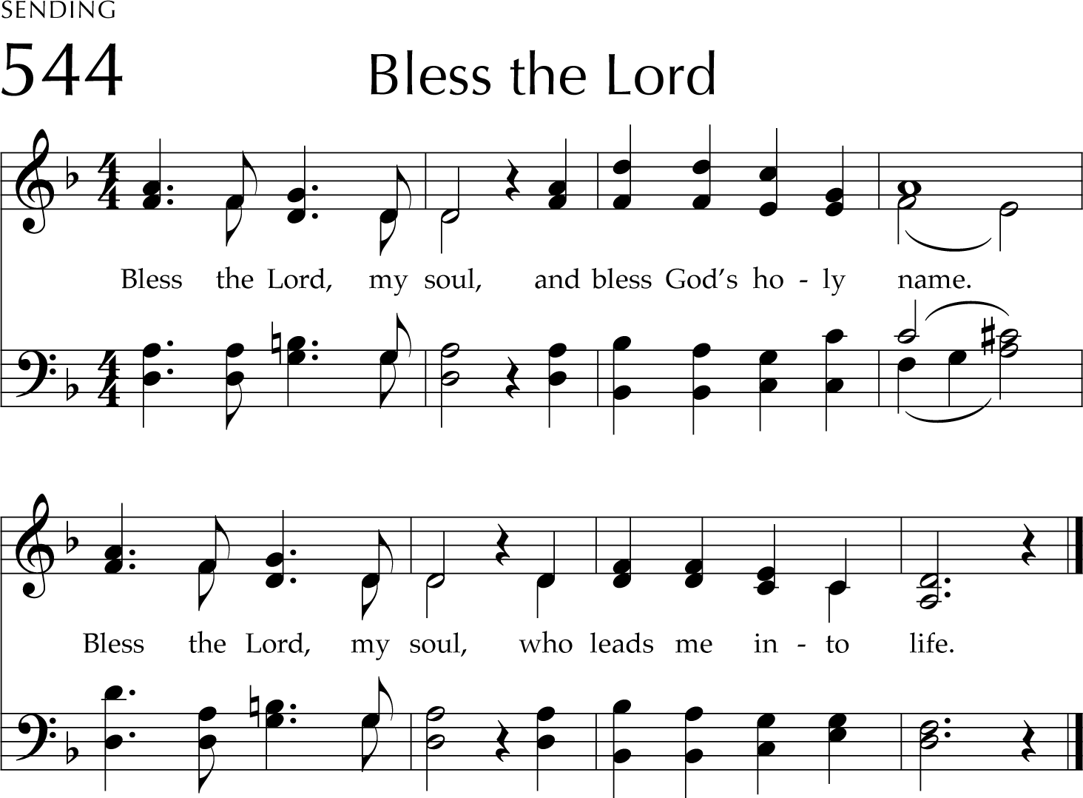
*We Celebrate God’s Forgiveness #544 in Glory to God “Bless the Lord”
TEXT: Taizé Community, 1984 MUSIC: Jacques Berthier, 1984 Text and Music © 1984, 1998 Les Presses de Taizé (admin. GIA Publications, Inc.)
BLESS THE LORD (Taizé) Irregular

*Sharing the Peace of Christ
One: The peace of our Lord Jesus Christ be with you all.
All: And also with you.

The Kirk Ringers "All Creatures of Our God and King," arr. Hal Hopson Time with the Children
Celebrating the Life of the Church

THE WORD

Prayer for Illumination
All: Gracious God, our way in the wilderness, guide us, by your Word, through these forty days, and minister to us with your Holy Spirit, so that we may be reformed, restored, and renewed; through Jesus Christ our Lord. Amen.

Scripture Reading: Mark 1:9-15
9 In those days Jesus came from Nazareth of Galilee and was baptized by John in the Jordan. 10 And just as he was coming up out of the water, he saw the heavens torn apart and the Spirit descending like a dove on him. 11 And a voice came from heaven, “You are my Son, the

Beloved; with you I am well pleased.” 12 And the Spirit immediately drove him out into the wilderness. 13 He was in the wilderness forty days, tempted by Satan; and he was with the wild beasts; and the angels waited on him.
14 Now after John was arrested, Jesus came to Galilee, proclaiming the good news of God,
15 and saying, “The time is fulfilled, and the kingdom of God has come near; repent, and believe in the good news.”

One: We live not by bread alone, but by every word that comes from God.
All: Thanks be to God.

Sermon “Swimming Upstream ” Rev. Marvin Lindsay

* We Affirm our Faith: “The Apostles’ Creed,” (traditional), pp. 14 in The Presbyterian Hymnal

GIVE THANKS
Prayers of the People The Lord’s Prayer
Our Father, who art in heaven, hallowed be thy name, thy kingdom come, thy will be done, on earth as it is in heaven. Give us this day our daily bread; and forgive us our debts, as we forgive our debtors; and lead us not into temptation, but deliver us from evil. For thine is the kingdom, and the power, and the glory, forever. Amen.

Practicing Abundant Generosity https://onrealm.org/FirstPresbyteri11244/give/now
Offertory: "Blessed Be the Lord," by Timothy Shaw, Chancel
Choir with Barry Wilhjelm , clarinet
- Doxology Hymn #592 “Praise God from Whom All Blessings Flow”
- Prayer of Dedication

LEAVE TO SERVE

*Hymn #298 “There’s a Wideness in God’s Mercy”

Charge and Benediction Choral Amen, Chancel Choir

Sending Music Variation on HEINLEIN - Christa Rakich Lucas Brown, organ

Please use the Postlude time and music to reflect on today’s worship experience and how it will support you in the week to come. Reprinted / Podcast / Streamed with Permission Under OneLicense #740987-A. All Rights Reserved.

WELCOME TO FIRST PRESBYTERIAN CHURCH! It is good to have you here in person or online. Please be in touch if you have news to share or would like more information or to talk to a pastor. Staff contact information is below. Read full announcements in our weekly email newsletter, available on the church website. Subscribe on the Contact Us tab.

FLOWERS: If you would like to place a live flower arrangement in the sanctuary, please contact Diane Thorne at dthorne31@comcast.net or 609-707-8122.
NURSERY care is available during worship (9:30 - 11:15) for those with young children. The nursery is located in the Preschool (level 1R) in the Red Balloon Room near the Preschool office.

SUNDAY SCHOOL: Parents, please register your preK-5th graders for Children's Church using the QR Code. PreK-Kindergarten must be signed out from the Sunday School room. First-fifth graders will reunite with their families in the Bean Parlor after worship.

WORSHIP NOTES
"Blessed Be the Lord," by Timothy Shaw, based on Psalm 72: 18-19
Blessed be the Lord.
Praise God's name evermore, alleluia.
Who alone does wondrous things; blessed be the Lord. May God's glory fill the earth, alleluia.

NEWS AND EVENTS

The Justice and Advocacy Committee (JAC) will meet in the Bean Parlor after worship this morning. Come share your ideas; everyone is welcome!

Goodbye Paper and Plastic at FPC! As Lent begins, we will no longer use single- use paper or plastic at our after worship fellowship and other church activities. We have plenty of plates, cups, bowls and utensils in the kitchen, Bean Parlor and Hospitality Suite. Efforts will be made to use environmentally-friendly napkins. If you are planning to serve food and have questions or want to help support this effort, please contact Rita Brown at rbrown6115@verizon.net. This is another step we are taking to help preserve God’s Creation.

Bible Study: Letter to the Romans will resume on February 22nd at 6:30pm on Zoom. Zoom link and passcode for all meetings can be found at http://www.haddonfieldpres.org/adult-education. Email npassante@haddonfieldpres.org for questions or more info.

Lenten small groups are forming now. This year we will study Meeting God in Paul, by Rowan Williams. Sign-up in the Bean Parlor or use this online form: https://forms.gle/yr5yqk4VsiQgyBsEA

Did You Personalize Your Hymnals Yet? Glory to God, the newest Presbyterian hymnal, is a remarkably thoughtful collection of spirituals and hymns created with an eye towards both diversity and tradition. In it, you will find all of the old standards like "A Mighty Fortress is Our God" and you will also find new standards like "Lift Every Voice and Sing". The Session is asking that each family purchase two hymnals at $25 a piece. You may also include a short memorial or dedication that will be affixed to the inside cover of your hymnals.
Please use the QR code to purchase and personalize your hymnals today!

Volunteers Needed for Prison Ministry: Those who participate in our ministry with the women of the Camden County Jail will tell you that the ministry is very rewarding and sorely needed. The ladies we see every other Friday greet us enthusiastically and are sincerely seeking to follow God. Our hope is that we can be a vehicle to reflect God’s forgiveness and love and offer them an alternative path. We feel very safe and secure entering the jail. Every time we go in the officers have to turn inmates away because we are only able to meet with 10 ladies at a time. If we had more volunteers, we could go in every Friday and see more inmates. The time investment is minimal once you go through the approval process. If you are interested in volunteering or finding out more information, please email Judy Blank (jmblank451@verizon.net).

THE PORCH BIBLE STUDY will meet at 2:00 PM on Tuesday, Feb. 27 in the Bean Parlor. We are returning to our study on Colossians & Philemon. We will be discussing the supremacy of Christ and serving Christ. All are welcome to our study and prayer time. For information, see Deb Nussbaum or Jill Mascena at church or email Deb at debranussbaum1987@gmail.com. Paul Urian will send out the Zoom link to all who are interested.

TRANSPORTATION MINISTRY: Need a ride to and from worship? To request transportation to worship, call the church at 856-429-1960. When you hear the auto attendant message, press 103 and you will go directly to the deacon voice mailbox. Leave a message and a deacon will call you back regarding your request. Transportation requests must be received no later than the Tuesday prior to the Sunday when the ride is needed. Make sure to leave your phone number and a convenient time to call. Please take note: if you call later than Tuesday at 4:00 PM, there may not be a deacon or church member available to drive you. We look forward to seeing you in worship! Questions? Call the church office, or Joan Fiorella at 856-889-9185.

PRESBYTERIAN WOMEN: All women of the church are invited to join Presbyterian Women for “Finding God in Ordinary Time” Women’s Retreat on Saturday, March 9th from 9:00 AM to noon, led by Christine Marie Eberle. Tentative schedule and presenter info is available on the Presbyterian Women’s page on the website and flyers can be found in the parlor. Pre-register by contacting Judy Grantham at judygrantham@comcast.net. Retreat fee is $20.

CHECK YOUR BLOOD PRESSURE: You can have your blood pressure taken in the Bean Parlor following morning worship. Screenings will occur monthly. If any medical professionals are interested in supporting this ministry, please email Linda O'Neill at ElonMail@yahoo.com or Bonnie Manskopf at BonnieManskopf@yahoo.com.

WORSHIP ATTENDANCE 02/11/24: 145 in person and 25 online.

FINANCIAL UPDATE
Pledge Giving: 130,457 Budget: 460,000
Non-pledge giving: 11,135 Budget: 160,000
Per Capita: 2,304 Budget: 11,000
Loose: 1,388 Budget: 11,000
Note: The Session adopted a 2024 budget with a projected shortfall of approximately $140,000. The shortfall will be covered by remaining Covid relief funds, small grants, and withdrawals from investment reserves.

PRAYER LIST (2/15/24)

Please pray for these individuals and situations throughout the week. If you would like to add a personal prayer request, please contact one of the pastors. In making requests on behalf of others, please obtain the permission of the person needing prayer. The requestor will have their name printed as the originator of the request. Pastors will revisit these requests every 30 days.

Prayers for the Church
- Pray for the people, government, and country of Ukraine as war continues.
- Pray for Gaza and the people of Israel and Palestine as war continues.
- Prayers for Bruce as he experiences treatment for pancreatic cancer and that Christ would hold him and his family in his loving arms (2/13-C. Carty).
- Please pray for the Reinicker family, in particular Andy’s mother Charlotte, who suffered a heart attack while in Connecticut. Praise the Lord her procedure went smoothly and pray for Charlotte’s recovery (2/11-pastors)
- Pray for Peggy Shannon that she would have complete recovery from a fall, and be with she and her physicians as they manage all health issues. Pray for Sam and Julie and Maggie that they would all feel God’s love (2/8-pastors)
- Please pray for Lillie as she receives treatment for leukemia. Pray for her complete healing
(2/7-pastors)
- Prayers for Jochen and Deb Bettag to feel strength and courage from the Lord. Jochen’s diagnosis is a very rare form of cancer (2/5-C. Carty)
- Continue to pray for Patrick and his family (2/5-pastors)
- Continue to keep Branson in your prayers as he studies abroad this semester (2/5-M. Wilson)
- Please keep a dear friend, Dorothy, in your prayers as she navigates several cancer diagnoses (1/31-C. Carty)
- Continue to pray for Mark as he recovers from gallbladder surgery (1/30-S. Oswald)
- Please pray for Patricia, Hannah, Selena, Rasheen, and Emani who are incarcerated. Pray for the ladies who are being released from jail (1/26-G. Ladies)
- Pray for the lives and families of Tamara and Kristy, and that each will get to go home to their families (1/26-G. Ladies)
- Pray for the restoration of June’s life (1/26-G. Ladies)
- Pray that Afi and her girls would be reunited (1/26-G. Ladies)
- Pray for Christina’s peace of mind and her parents’ health (1/26-G. Ladies)
- Pray for Enza, her children, and her husband (1/26-G. Ladies)
- Pray for Krystle’s health and safety, and that of her family; pray also for her prosperity following her impending release (1/26-G. Ladies)
- Pray that the truth comes to light in Morgan’s case, that there will be justice for her two daughters, and pray for her sister’s release from addiction (1/26-G. Ladies)
- Please pray for Malea- specifically her relationships with significant others (1/26-G. Ladies)
- Pray for Julia, and her daughter Nava. Pray also for Julia’s mother Sophia. May the Lord care and deliver this family (1/26-G. Ladies)
- Pray for Chanel’s release and that she would be reunited with her husband (1/26-G. Ladies)

- Please pray for Jessica Devietro who is living with cancer (1/22-L. Sommers)
- Pray the God’s Spirit would be with Heather and the rest of the McCall family, following her dad’s sudden passing after falling on ice (1/22-L. Sommers)
- Keep Randi in your prayers as she waits patiently for a diagnosis (1/17-C. Carty)
- Continue in prayer for Vivian, who has been diagnosed with lymphoma (1/16-J. Grantham).
- Prayers for 4-year-old Ellie and her parents as she begins treatment for lymphoma(1/15-L.Carpenter)

CHURCH STAFF
Rev. Marvin Lindsay, Ph.D., Senior Pastor and Head of Staff- mlindsay@haddonfieldpres.org The Rev. Nikki Perrine Passante, Associate Pastor – npassante@haddonfieldpres.org
Peter Leibensperger, Minister of Music – pleibensperger@haddonfieldpres.org Lucas Brown, Principal Organist – lbrown@haddonfieldpres.org
Nancy Ruth Wainwright, Director of Children’s Choirs – nancyruthw@comcast.net Marisa McGovern, Preschool Director – preschool@haddonfieldpres.org
Kris Bean, Business Manager – kbean@haddonfieldpres.org Travis Bogetti, Building Manager – tbogetti@haddonfieldpres.org Ed Hess, Community Caseworker – edwh517@aol.com

(856) 429-1960 www.haddonfieldpres.org

All women of the church are invited
to a

Women's Retreat Morning
FINDING GOD
TIME

Presented by
Cfiristine :Marie 'Eberfe

Where is God in all this? That's a question many are moved to ask in confusing and stressful times, but it's also an excellent question for every day. In this retreat morning, we will explore different ways to notice God's presence in our daily lives, from the simple joys of nature to the inevitable seasons of heartbreak, and everything in between.
First Presbyterian Church of Haddonfield
March 9, 2024
Saturday, 9:00 a.m. - Noon

Presenter

Christine Marie Eberle passionately connects spirituality, Scripture, and everyday life. She is the author of two books of daily meditations: Finding God in Ordinary Time and Finding God Abiding. A campus minister in higher education for 26 years, Christine now devotes her time to writing, speaking, and retreat facilitation. You can learn more and follow her at christine-marie-eberle.com.

Tentative Schedule

8:30- 9:00 Registration and Refreshments
9:00-10:20 Presentations
10:20-10:40 Stretch Break with Refreshments 10:40 -12:00 Presentations
12:00 Dismissal with Blessing

Open to all women of the church.
Retreat Fee: $20.00
Pre-register with Judy Grantham (judygrantham@comcast.net) by March 4.

Syonsorea6y Tres6yterian Women

